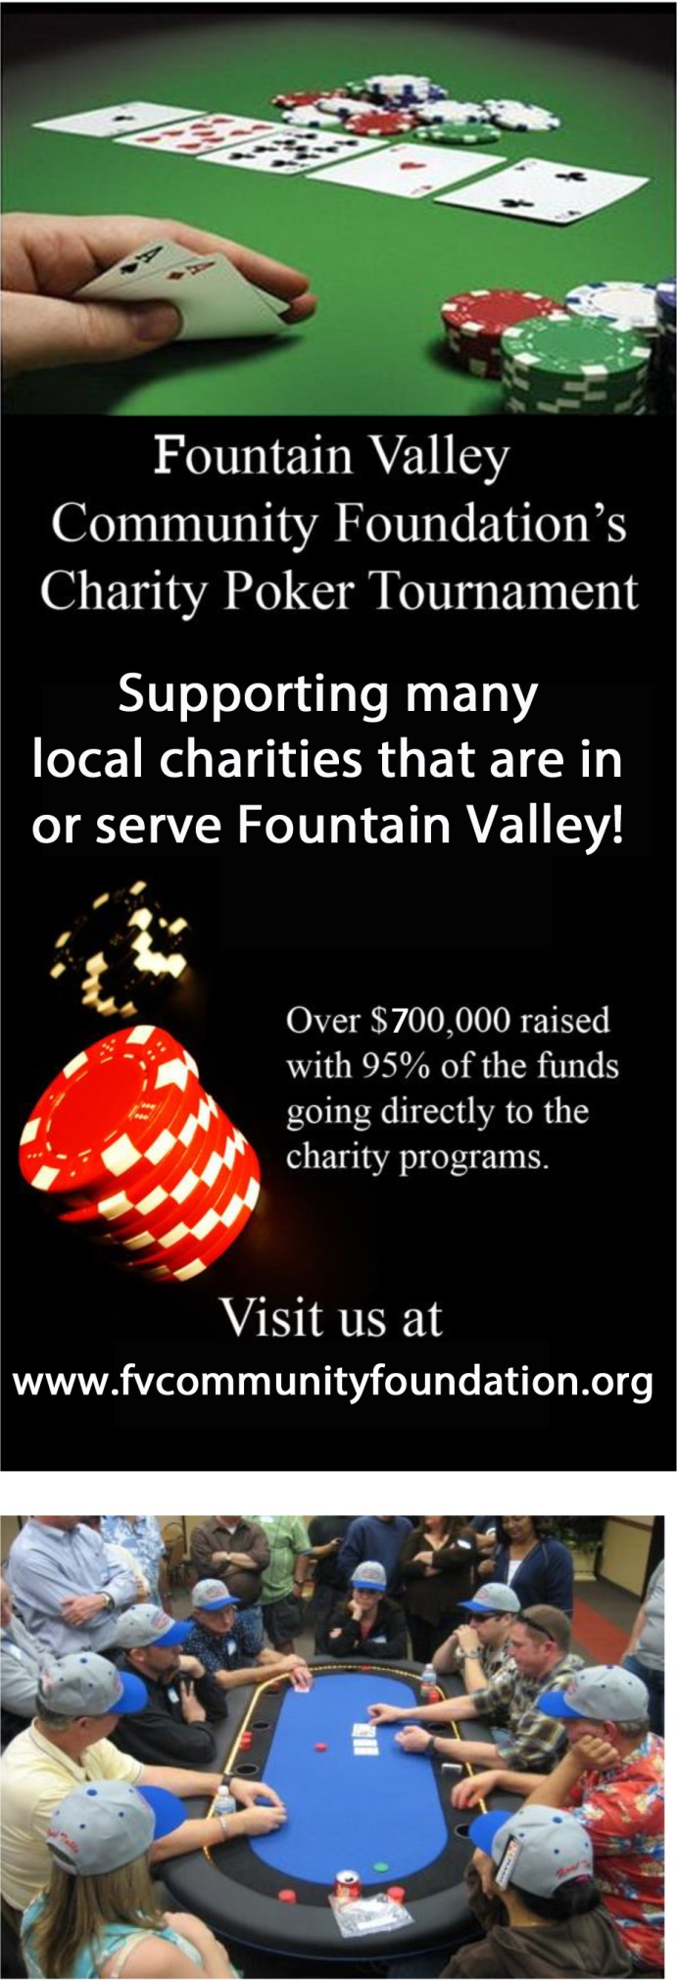
No Limit Texas Hold'em

When: Saturday, November 5th, 2016
Registration 5:15pm
First Hand is dealt at 6:00pm

Entry: $25 Preregistration/$20 Rebuys until 8:00pm
$30 Registration after October 29th

Where: The Center at Founder’s Village
17967 Bushard St, Fountain Valley
(corner of Talbert & Bushard)

Silent Auction, Food and Refreshments and FUN!!!

100% of your registration fee goes directly to the charity of your choice

Register online at WWW.fvcommunityfoundation.org

or

Mail entry and make checks payable to:

Fountain Valley Community Foundation
10200 Slater Ave.
Fountain Valley, CA 92708

For more Info contact:
Matt Taylor
714-309-6451
wcdebate@aol.com

Be sure to select FVHS Vocal Music as your benefitting organization!

